Overall review regarding feedback received from development review questionnaire and design review meeting, alongside the meeting minutes.
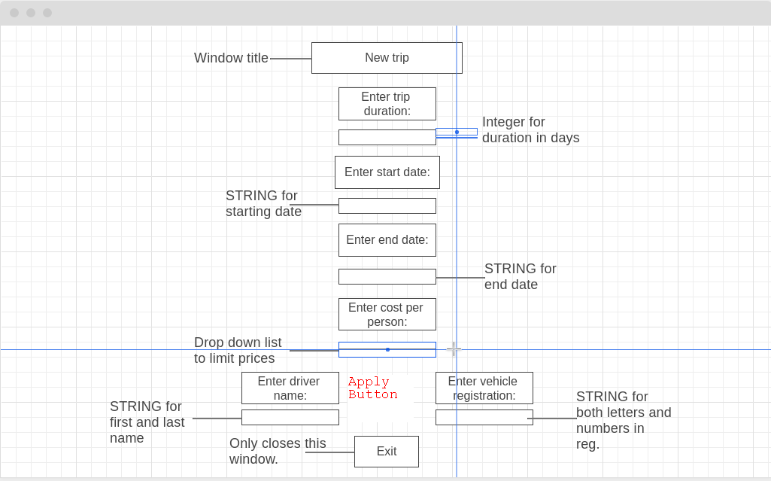
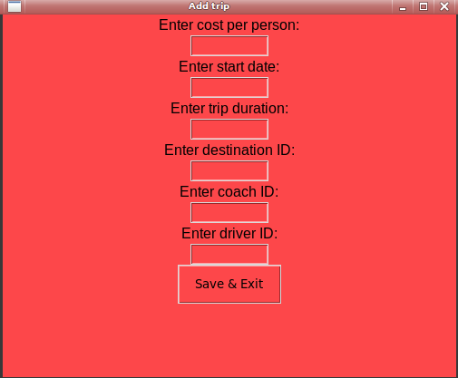
Throughout the project, the quality of the database has improved based upon the feedback given during the design review. My interface initially featured the trip page, which collectively stored data about the destination, driver and coach, which was terrible in terms of the level of normalisation the database featured. Mike initially brought up this issue, in the design review meeting regarding the use of foreign keys and bookings. He wanted to make sure that a booking can only be made if the trip that was being booked already existed, which resulted in the proper setup of foreign keys between each table. This should prevent fields that require dependant data such as the destination_id in trip table, from storing non-existent data (trips that don’t exist), overall preventing levels of data redundancy. Alongside this, the amount of unnecessary fields featured in the trip window would also be reduced as a result of the level of organisation used between tables, improving the visual appeal of each table.

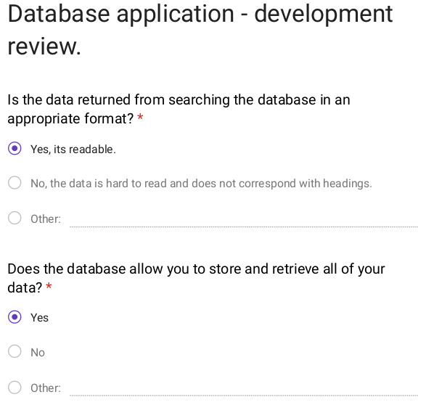
The database is suitable for use in Mikes scenario, as it provides all of the appropriate fields needed to store data including customer, trip, booking, coach, driver and destination tables. During my development questionnaire, mike confirmed that all the data he wants to retrieve is accessible through the interface, and he is also able to insert all data into the database. Which further shows that all the database functions are properly optimised and working.

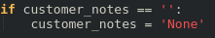
Another feature that was also added according to the development review was validation for presence check, as discussed in the test plan. This can be seen in the customer table where the special need value is automatically replaced with None if there is not a value present.

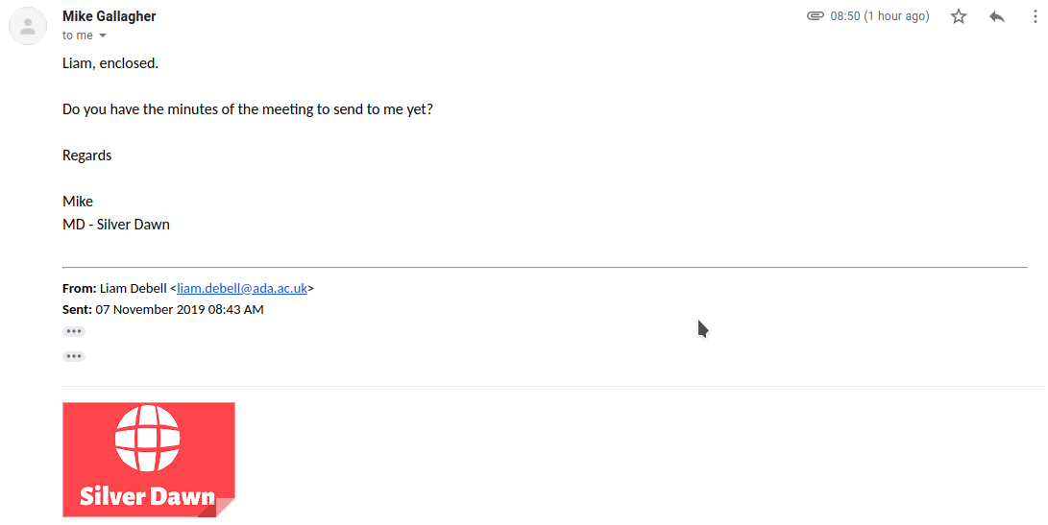
In terms of the legal and ethical constraints outlined in the requirements specification, all legal constraints have been met, as all content utilised is property of silver dawn coaches. No external sources have been used to formulate the database or interface, but instead uses an open source library Guizero, alongside the provided logo received from Mike in this email:
Alongside this, all decisions made in terms of the design and development have been made according to the ethical points discussed in the requirements specification. “Ethically it is important that both privacy and trust are considered in terms of the chosen developer or development team, as developers will have access to sensitive customer information.”, all data provided by Mike has been saved locally, and within a private github meaning data was kept within employees only.

Some technology constraints have included the design and optimisation of the interface, as discussed with Mike in the development review questionnaire.
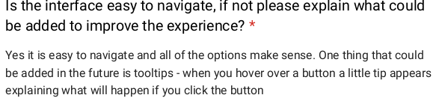
The tooltips requested here cannot be added within the time constraints set out by Mike. The Guizero library does not include a tooltips function, meaning any tooltip function would have to be hardcoded into the front end application. This process would exceed the time frame, and has therefore been outlined as a future prospect for further development.
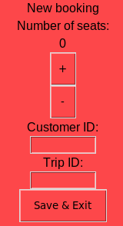
Some of the strengths of this database application is the program should work on all operating systems with graphical support. Python, the programming language used, is universal as it runs on its own interpreter meaning no precompiled application is required for transfer between operating systems. This might become a problem in the future if Silver Dawn choose to update there computers to a different operating system or manufacturer.
One weakness on the other hand, is that the database might require maintenance if Mike enters information incorrectly, which is why in some aspects of the interface I have applied an incrementor or drop down list, reducing human error.

